LAB EXPERIMENT RECORD
Set 29: Student Academic Performance

Department | AIML
Course Code / Course Name | DSA0601 / Data Handling and Visualization
Experiment | Data Visualization using R and Tableau
Name | HYDERABAD MOHAMMED NAWAZ
Register Number | 192325060
Date | 22 October 2026
Day | Thursday

Aim
To visualize student academic performance data using a stacked area chart, a boxplot and a density plot in R, and to design an interactive scatterplot with an Age filter in Tableau.
Dataset: Student Academic Performance
Student_ID | Age | Study_Hours | Attendance (%) | Test_Score | Participation_Score
S1 | 19 | 12 | 90 | 85 | 8
S2 | 21 | 8 | 70 | 70 | 7
S3 | 20 | 15 | 95 | 92 | 9
S4 | 22 | 10 | 85 | 80 | 8
S5 | 23 | 7 | 60 | 65 | 6

PROGRAM 1: Stacked Area Chart of Test and Participation Scores
Using R, create a stacked area chart showing Test_Score and Participation_Score across students. Analyze trends.
# Create dataset
students <- data.frame(
Student_ID = c("S1", "S2", "S3", "S4", "S5"),
Test_Score = c(85, 70, 92, 80, 65),
Participation_Score = c(8, 7, 9, 8, 6)
)
# Convert data into long format
library(ggplot2)
library(tidyr)
data_long <- pivot_longer(
students,
cols = c(Test_Score, Participation_Score),
names_to = "Score_Type",
values_to = "Score"
)
# Create stacked area chart
ggplot(data_long, aes(x = Student_ID, y = Score,
fill = Score_Type, group = Score_Type)) +
geom_area(position = "stack", alpha = 0.8) +
labs(
title = "Stacked Area Chart of Student Scores",
x = "Student ID",
y = "Score",
fill = "Score Type"
) +
scale_fill_manual(values = c("Test_Score" = "skyblue",
"Participation_Score" = "orange")) +
theme_minimal()
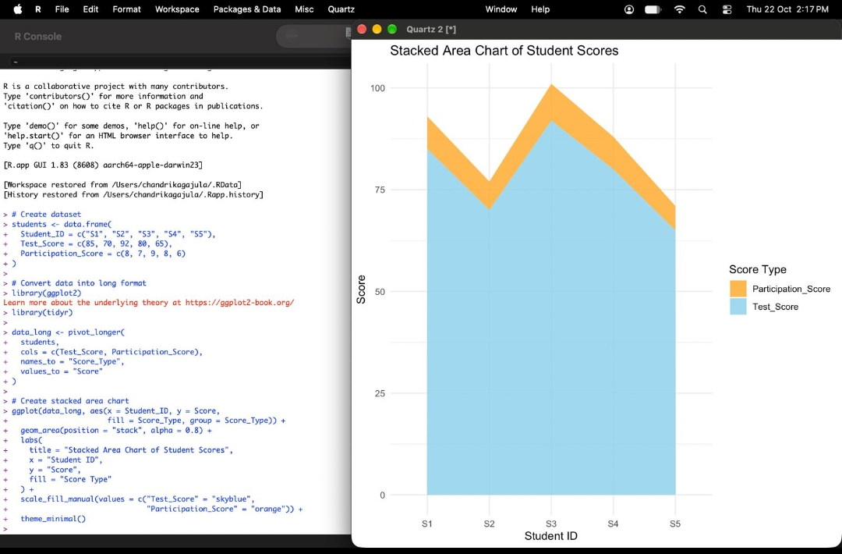
Output 1: Stacked Area Chart of Student Scores
Trend Analysis: The combined height (Test_Score + Participation_Score) is 93 for S1, 77 for S2, 101 for S3, 88 for S4 and 71 for S5. The total drops from S1 to S2, reaches its peak at S3, and then falls steadily to its lowest value at S5. The Test_Score band forms most of the stack, while the Participation_Score band is thin because its values (6-9) are much smaller than the test scores (65-92). Both bands rise and fall together: S3 has the highest test score and participation score, and S5 has the lowest.
PROGRAM 2: Boxplot of Study Hours by Attendance Quartiles
Generate a boxplot of Study_Hours grouped by Attendance quartiles with axis labels, title and colors for each quartile. Identify the median, interquartile range and any outliers.
# Create dataset
students <- data.frame(
Student_ID = c("S1", "S2", "S3", "S4", "S5"),
Study_Hours = c(12, 8, 15, 10, 7),
Attendance = c(90, 70, 95, 85, 60)
)
# Attendance quartiles
q <- quantile(students$Attendance)
q
# Create four attendance groups
students$Attendance_Quartile <- cut(
students$Attendance,
breaks = c(-Inf, q[2], q[3], q[4], Inf),
labels = c("Q1", "Q2", "Q3", "Q4"),
include.lowest = TRUE
)
print(students)
# Draw a clear boxplot
boxplot(
Study_Hours ~ Attendance_Quartile,
data = students,
col = c("skyblue", "lightgreen", "orange", "pink"),
main = "Study Hours by Attendance Quartiles",
xlab = "Attendance Quartile",
ylab = "Study Hours",
ylim = c(5, 17),
yaxt = "n",
outline = TRUE,
cex.main = 1.2,
cex.lab = 1.1
)
axis(2, at = 5:17, las = 1)
stripchart(
Study_Hours ~ Attendance_Quartile,
data = students,
vertical = TRUE,
method = "jitter",
pch = 19,
col = "black",
add = TRUE
)
grid(nx = NA, ny = NULL, col = "gray80", lty = "dotted")
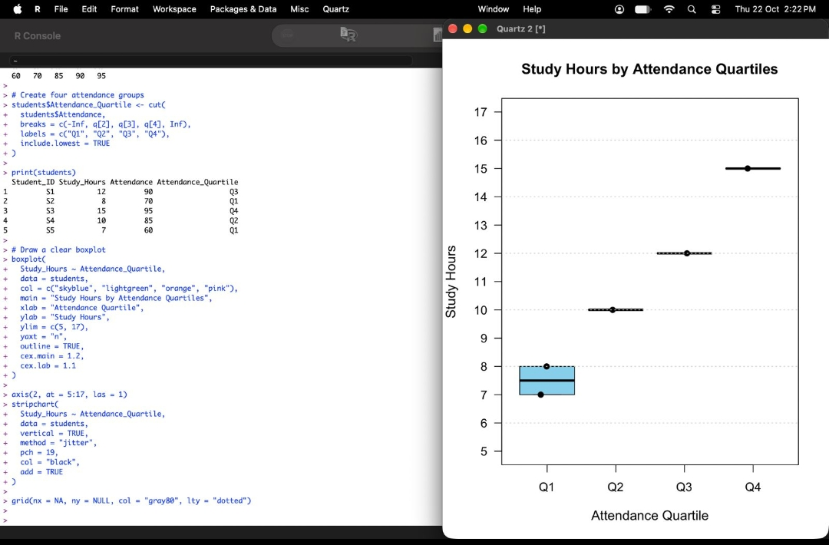
Output 2: Study Hours by Attendance Quartiles
Interpretation: Attendance quartiles are 60, 70, 85, 90 and 95, so Q1 = S2 and S5, Q2 = S4, Q3 = S1 and Q4 = S3. The median study hours are 7.5 (Q1), 10 (Q2), 12 (Q3) and 15 (Q4), showing that study hours increase steadily as attendance increases. Only Q1 has two students, so only Q1 shows a box, with an interquartile range of 1 hour (7 to 8). Q2, Q3 and Q4 each contain a single student, so their IQR is 0 and the box collapses to a line at the median. No outliers are present in any quartile.
PROGRAM 3: Density Plot of Test Scores
Construct a density plot for Test_Score to evaluate the score distribution and outliers.
# Create dataset
students <- data.frame(
Student_ID = c("S1", "S2", "S3", "S4", "S5"),
Test_Score = c(85, 70, 92, 80, 65)
)
# Create density plot
library(ggplot2)
ggplot(students, aes(x = Test_Score)) +
geom_density(fill = "lightblue",
color = "blue",
alpha = 0.7,
adjust = 1.5) +
labs(
title = "Density Plot of Student Test Scores",
x = "Test Score",
y = "Density"
) +
theme_minimal()
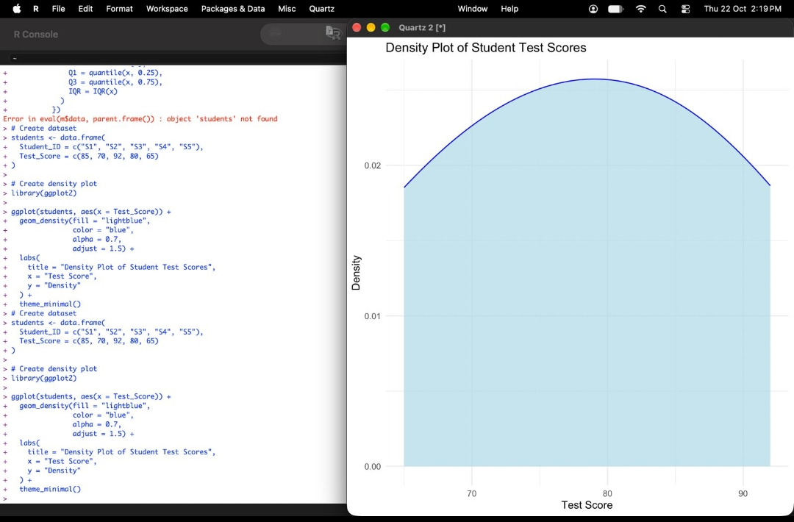
Output 3: Density Plot of Student Test Scores
Observation: The density curve has a single smooth peak near 80, so most scores are concentrated around 75-85, with lower density towards both ends (65 and 92). The mean is 78.4 and the median is 80, so the distribution is approximately symmetric with a very slight left tilt. The quartiles are Q1 = 70 and Q3 = 85 (IQR = 15), giving outlier limits of 47.5 and 107.5. All scores lie within these limits, so there are no outliers.
PROGRAM 4: Interactive Scatterplot of Study Hours vs Test Score
In Tableau, design an interactive scatterplot with Study_Hours on the X-axis and Test_Score on the Y-axis, coloured by Participation_Score, with filters for Age.
# Create dataset
students <- data.frame(
Student_ID = c("S1", "S2", "S3", "S4", "S5"),
Age = c(19, 21, 20, 22, 23),
Study_Hours = c(12, 8, 15, 10, 7),
Test_Score = c(85, 70, 92, 80, 65),
Participation_Score = c(8, 7, 9, 8, 6)
)
# Load ggplot2
library(ggplot2)
# Create scatterplot
ggplot(students, aes(
x = Study_Hours,
y = Test_Score,
color = Participation_Score
)) +
geom_point(size = 4) +
labs(
title = "Study Hours vs Test Scores",
x = "Study Hours",
y = "Test Score",
color = "Participation Score"
) +
scale_color_gradient(low = "blue", high = "red") +
theme_minimal()
Tableau Steps (interactive scatterplot):
1. Connect Tableau to the Student Academic Performance dataset (Excel/CSV file with the six columns).
2. Drag Study_Hours to Columns and Test_Score to Rows; right-click each pill and choose Dimension/Measure as needed so that each student is a separate point.
3. Drag Student_ID to Detail so that every student appears as one mark, and set the Marks type to Circle.
4. Drag Participation_Score to Color and choose a continuous colour palette (blue to red) to colour the points.
5. Drag Age to Filters, select Show Filter and choose Range of Values (slider) so that students can be filtered by age.
6. Drag Student_ID, Age and Participation_Score to Tooltip, add the axis titles and the title "Study Hours vs Test Scores", and use Show Filter and the colour legend for interactivity.
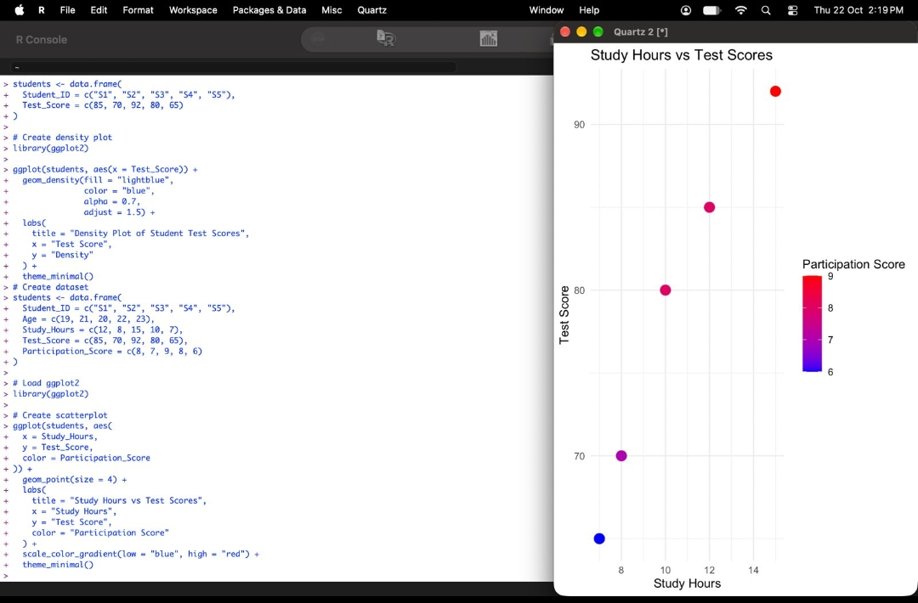
Output 4: Study Hours vs Test Scores (coloured by Participation Score)
Observation: The points rise from the lower left to the upper right, showing a strong positive relationship between Study_Hours and Test_Score (correlation coefficient r is about 0.98). S3 (15 hours, score 92) has the highest score and the highest Participation_Score (red), while S5 (7 hours, score 65) has the lowest score and the lowest Participation_Score (blue). Students who study more hours also tend to participate more in class.
Note: The scatter plot output shown above was generated in R using ggplot2 with the same variables and colour mapping. In Tableau, the same view is built with the steps listed above, with the additional Age filter for interactivity.
Procedure
1. Create the student data frame in R with Student_ID, Age, Study_Hours, Attendance, Test_Score and Participation_Score.
2. Convert Test_Score and Participation_Score to long format using pivot_longer() and draw the stacked area chart with geom_area(position = "stack").
3. Find the attendance quartiles using quantile(), create four groups with cut(), and draw the boxplot of Study_Hours with boxplot(), adding a title, axis labels and colours.
4. Draw the density plot of Test_Score using geom_density() in ggplot2 and check for outliers using the IQR rule.
5. In Tableau, place Study_Hours on Columns, Test_Score on Rows, Participation_Score on Color and Age in Filters to build the interactive scatterplot.
6. Run each program, record the output screenshots and analyse the trends, medians, interquartile ranges and outliers.
Result
The student academic performance data was successfully visualized. The stacked area chart showed that test scores and participation scores move together, the boxplot showed that median study hours increase with attendance quartile with no outliers, the density plot showed a single-peaked test-score distribution with no outliers, and the scatterplot showed a strong positive relationship between study hours and test scores.
Key R Functions Used
Function | Purpose
data.frame() | Creates the student dataset.
pivot_longer() | Converts wide data into long format.
ggplot() / geom_area() | Creates the stacked area chart.
quantile() / cut() | Finds attendance quartiles and creates the groups.
boxplot() / stripchart() | Draws the boxplot and overlays the data points.
geom_density() | Creates the density plot of Test_Score.
geom_point() | Creates the scatterplot points.

